A000-AM,C-Taino-Tripointer-Type I-Anthropomorphic-Porphyritic Andesite-1000 CE

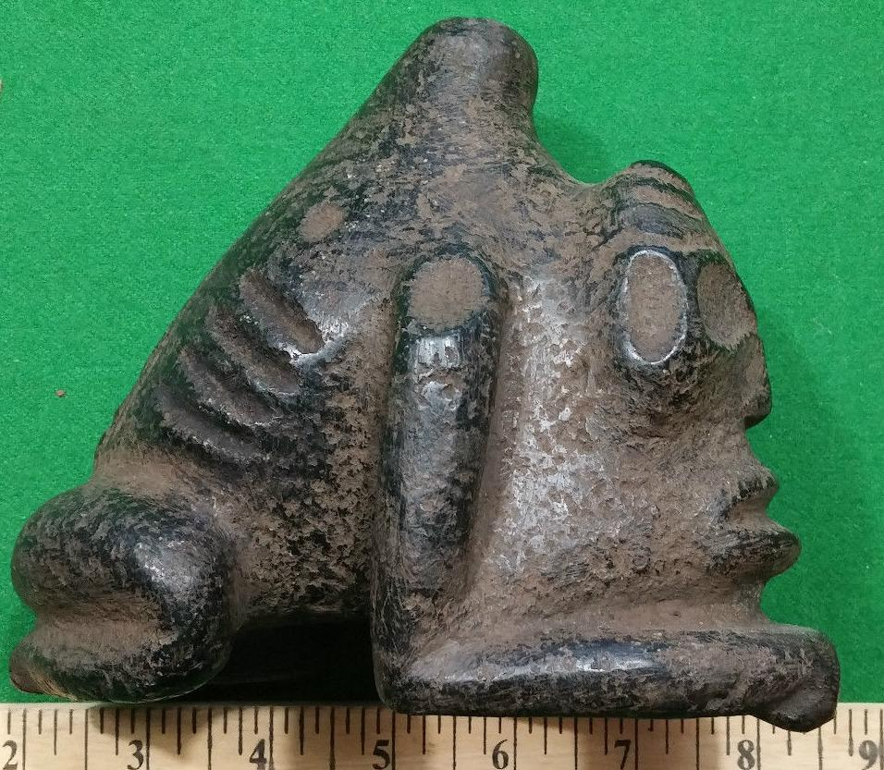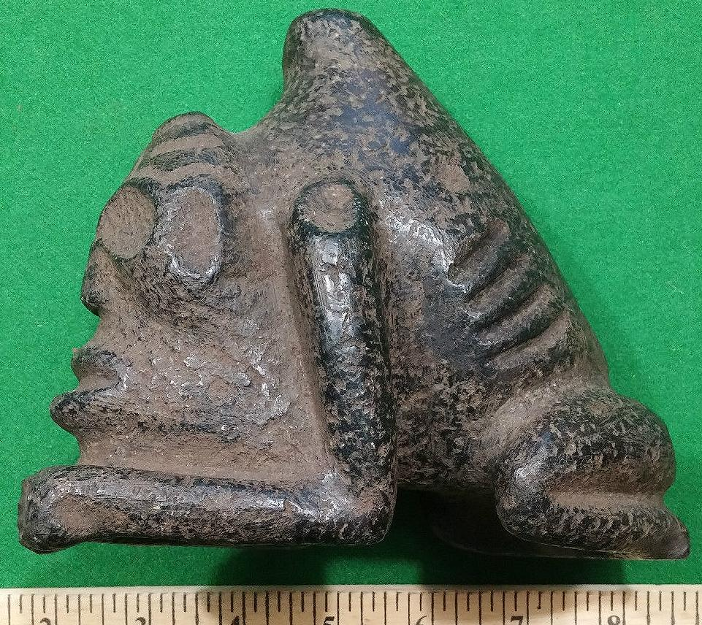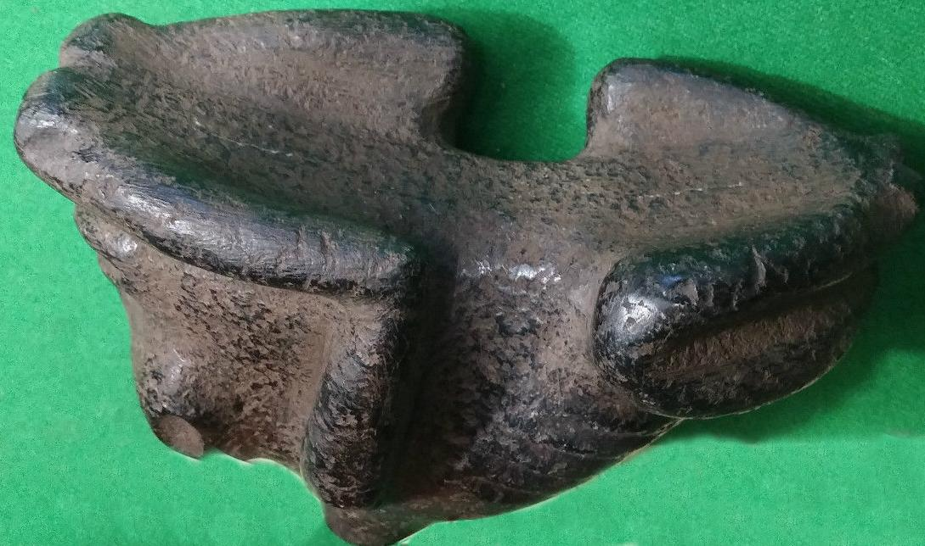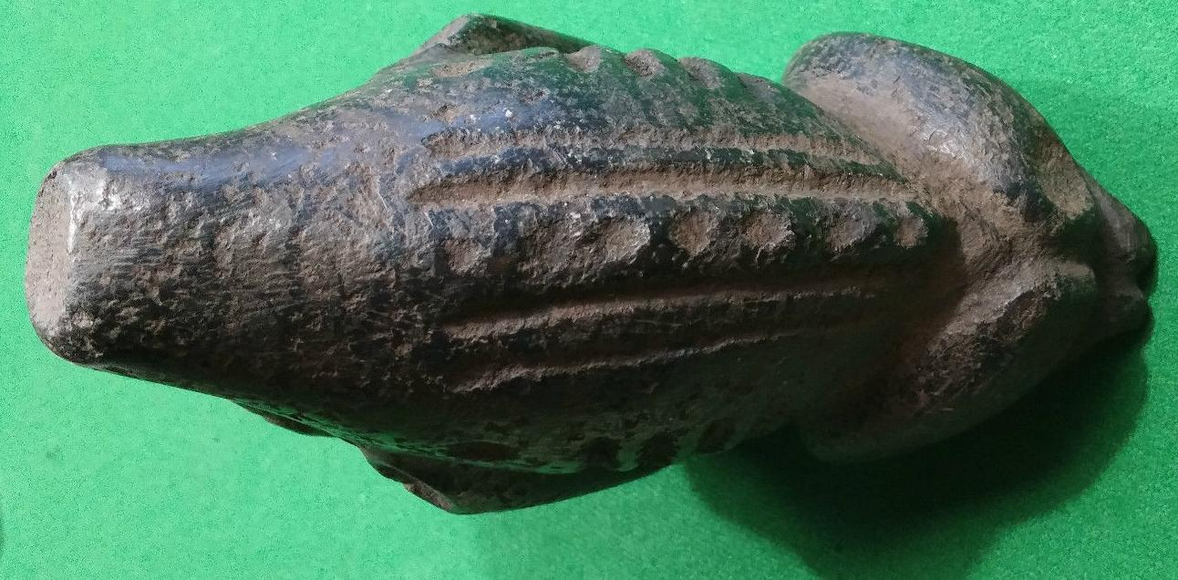

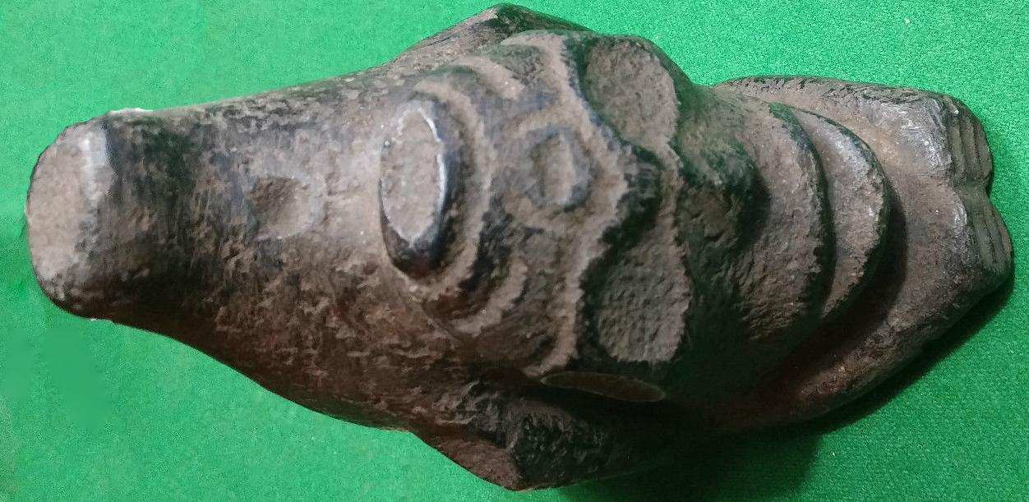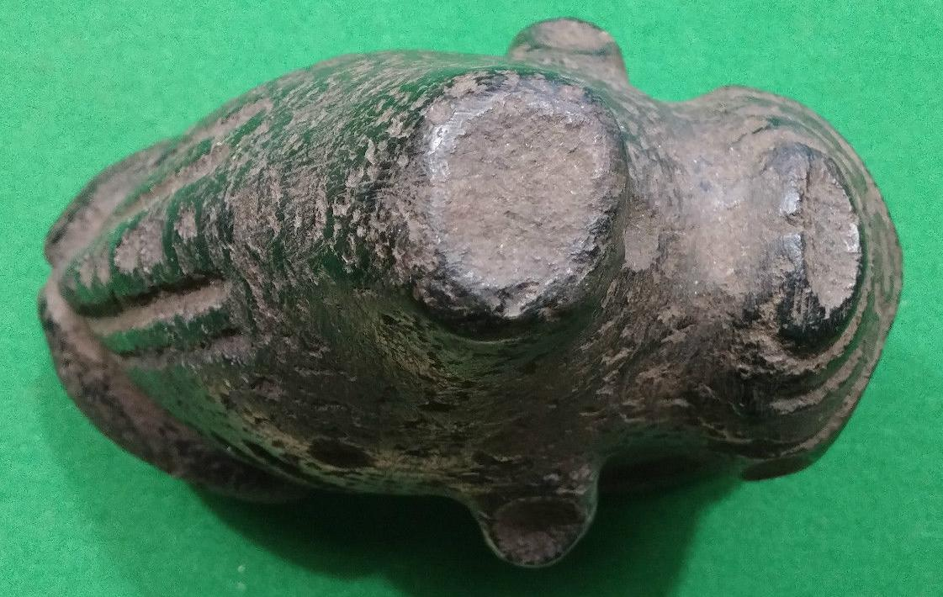

Figs. 1-6. AM,C-Taino-Tripointer-Type I-Anthropomorphic-Porphyritic Andesite-1000 CE

Case No.: 17

**Accession No.**

**Formal Label:** AM,C-Taino-Tripointer-Type I-Anthropomorphic-Porphyritic Andesite-1000 CE

**Display Description:**

This tripointer was obviously used in the *Batu* game as it was affixed to a *Yuke* because if the hafting across the middle section. Its significance therefore is that its connection to a particular *Yuke* and team that won a contest is that it participated in the ceremonies attendant to that event.

**LC Classification: F1909**

**Date or Time Horizon: 1000 CE**

**Geographical Area: Caribbean**

**Map:**

**GPS coordinates:**

**Cultural Affiliation: Taino**

**Media:**

**Dimensions:**

**Weight:**

**Condition:**

**Provenance:**

**Discussion:**

**References:**